344C5
Popa Iulia

Laboratory 2 - Memory Monitoring (Linux)

Task 01. Memory usage

The difference between do_allocate() and do_append() is that the first one allocates memory for storing all the elements in the array (from the start), while the second one adds a new element with every iteration.
- vmstat output for do_append:
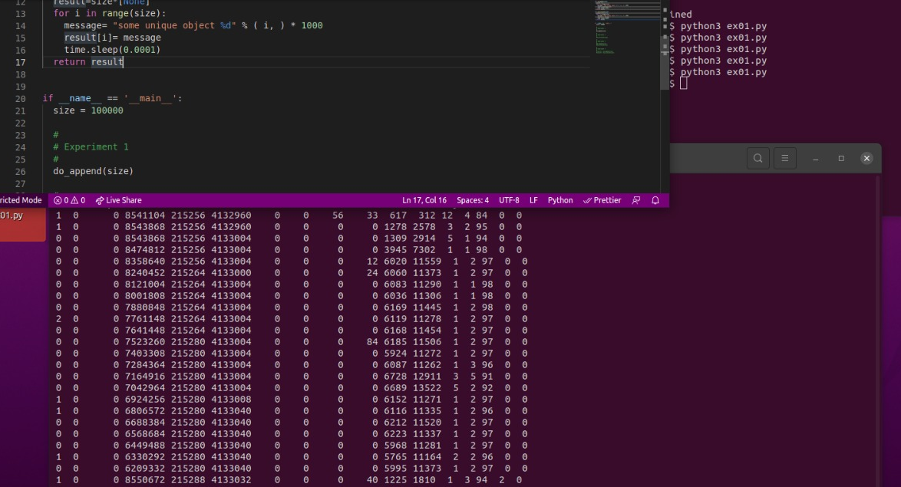

- vmstat output for do_allocate:
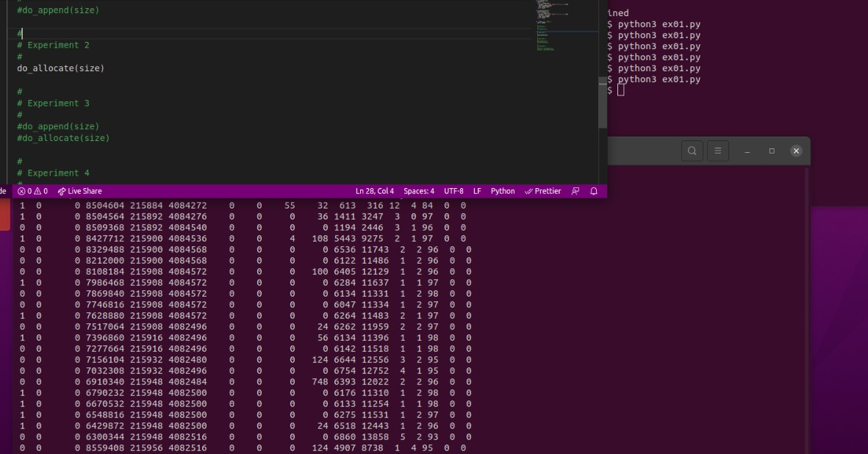
Cache memory for 1 > Cache memory for 2
- vmstat output for Experiment 3:
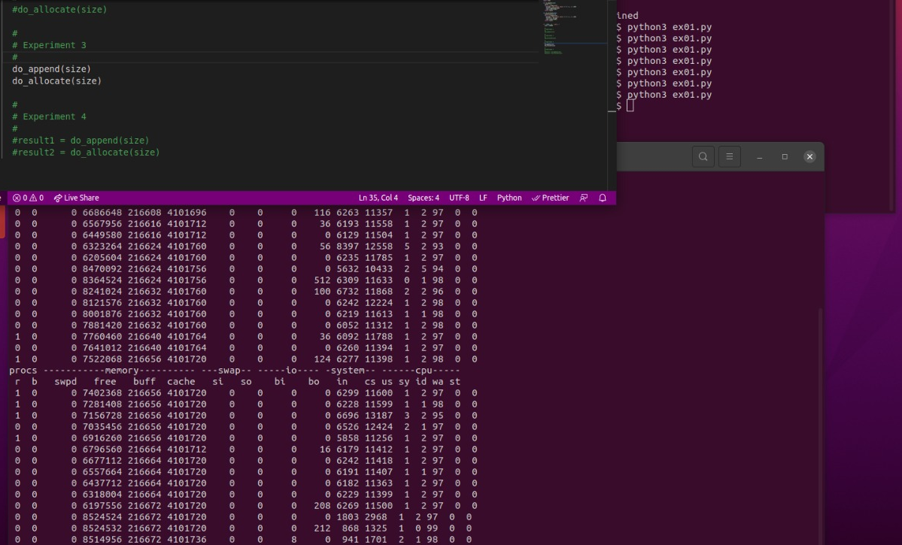
Free memory: ↗️↘️↗️

- vmstat output for Experiment 4:
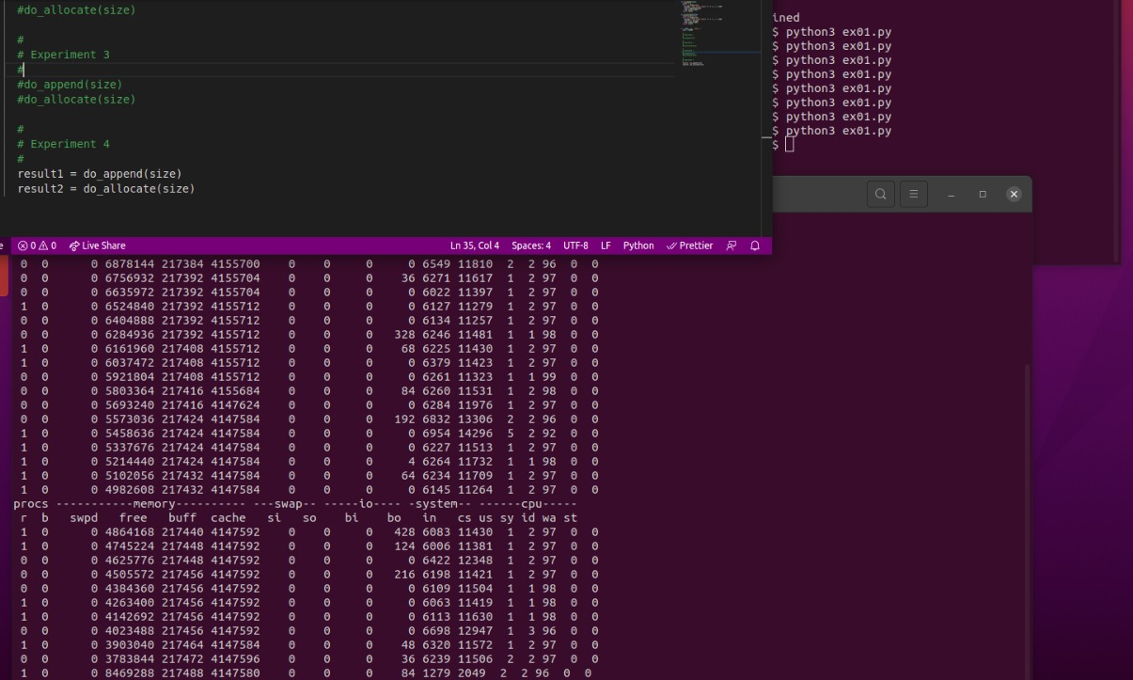
Free memory: ↘️↗️
Cache memory for 3 increases, while cache memory for 4 decreases.

Experiment 3 & 4 >>>>> Experiment 1 & 2
Changed the code in do_append():
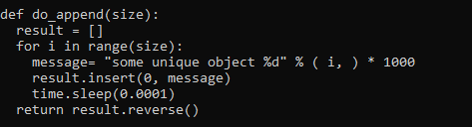

Task 02. Swap space
- Swap File

iulia@iulia-LenovoG6:~/Desktop$ sudo swapoff -a
iulia@iulia-LenovoG6:~/Desktop$ sudo dd if=/dev/zero of=/swapfile bs=1024 count=$((4 * 1024 * 1024))
4194304+0 records in
4194304+0 records out
4294967296 bytes (4,3 GB, 4,0 GiB) copied, 6,41845 s, 669 MB/s
iulia@iulia-LenovoG6:~/Desktop$ sudo chmod 600 /swapfile
iulia@iulia-LenovoG6:~/Desktop$ sudo mkswap /swapfile
Setting up swapspace version 1, size = 4 GiB (4294963200 bytes)
no label, UUID=74054a1f-8f2c-4dae-bc7f-23bf98c0b47b
iulia@iulia-LenovoG6:~/Desktop$ sudo swapon /swapfile
iulia@iulia-LenovoG6:~/Desktop$ swapon --show
NAME TYPE SIZE USED PRIO
/swapfile file 4G 0B -2

-> created new swapfile (4GB dimension)
-> added line in /etc/fstab

- Does it work?
vmstat output after swap modifications:
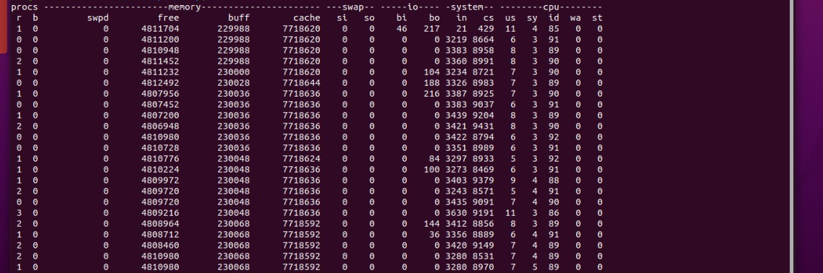
Created two swap files (with prio 10 and 20):
iulia@iulia-LenovoG6:~/Desktop$ sudo swapoff -a
iulia@iulia-LenovoG6:~/Desktop$ sudo dd if=/dev/zero of=/swapfile2 bs=1024 count=$((2 * 1024 * 1024))
2097152+0 records in
2097152+0 records out
2147483648 bytes (2.1 GB, 2.0 GiB) copied, 15.6518 s, 137 MB/s
iulia@iulia-LenovoG6:~/Desktop$ sudo chmod 600 /swapfile2
iulia@iulia-LenovoG6:~/Desktop$ sudo mkswap /swapfile2
Setting up swapspace version 1, size = 2 GiB (2147479552 bytes)
no label, UUID=3b09d421-0d75-4470-bfa9-5eaf795de510
iulia@iulia-LenovoG6:~/Desktop$ sudo swapon -p 10 /swapfile2
iulia@iulia-LenovoG6:~/Desktop$ swapon --show
NAME TYPE SIZE USED PRIO
/swapfile file 4G 0B -2
/swapfile2 file 2G 0B 10

iulia@iulia-LenovoG6:~/Desktop$ sudo dd if=/dev/zero of=/swapfile3 bs=1024 count=$((3 * 1024 * 1024))
3145728+0 records in
3145728+0 records out
3221225472 bytes (3.2 GB, 3.0 GiB) copied, 23.2876 s, 138 MB/s
iulia@iulia-LenovoG6:~/Desktop$ sudo chmod 600 /swapfile3
iulia@iulia-LenovoG6:~/Desktop$ sudo mkswap /swapfile3
Setting up swapspace version 1, size = 3 GiB (3221221376 bytes)
no label, UUID=924a4bca-aa1b-4293-a58f-98c0e48cd739
iulia@iulia-LenovoG6:~/Desktop$ sudo swapon -p 20 /swapfile3
iulia@iulia-LenovoG6:~/Desktop$ swapon --show
NAME TYPE SIZE USED PRIO
/swapfile file 4G 0B -2
/swapfile2 file 2G 0B 10
/swapfile3 file 2G 0B 20

Task 03. Kernel Samepage Merging
- Checked if ksm is on and modified config files.
- vmstat-wa -S m 1 -> memory state:
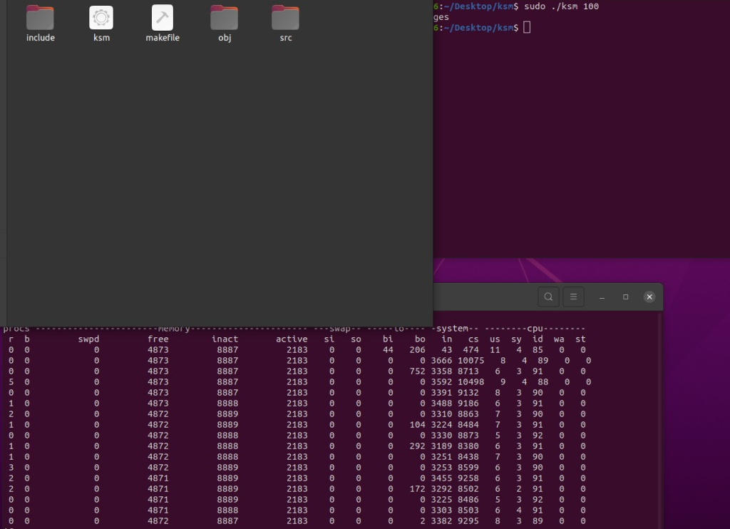
Active memory increased and then got back to the initial value.

watch -n 0 cat /sys/kernel/mm/ksm/pages_sharing -> virtual pages allocated by ksm:
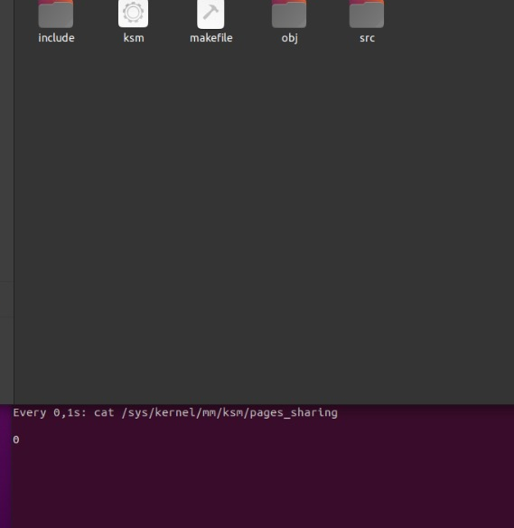

Task 04. Intel PIN
- Setup

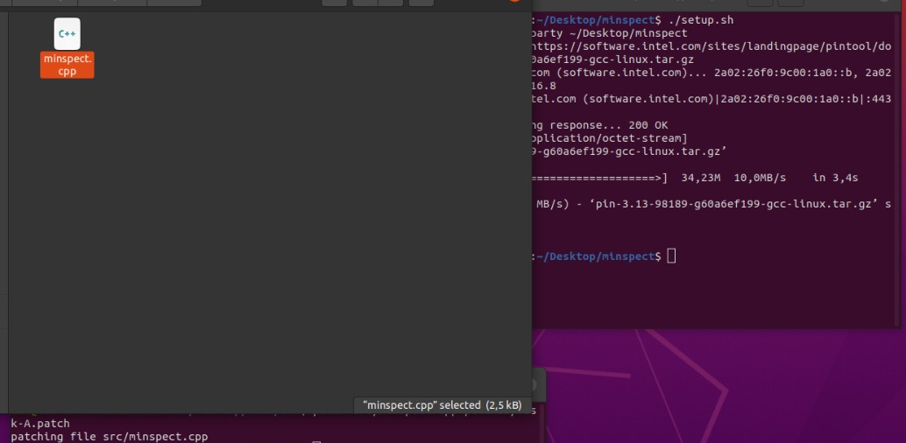

Code changed:
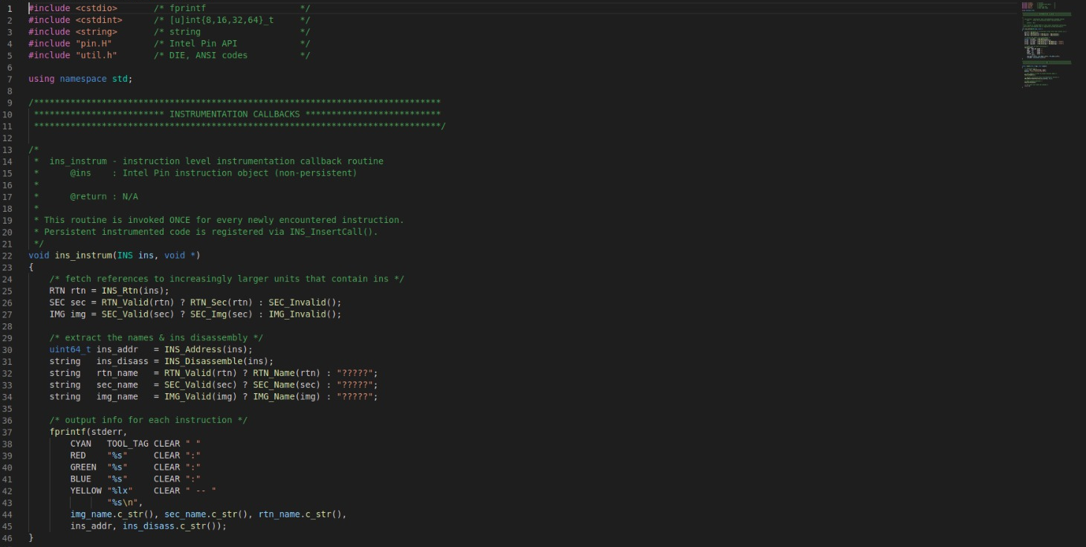
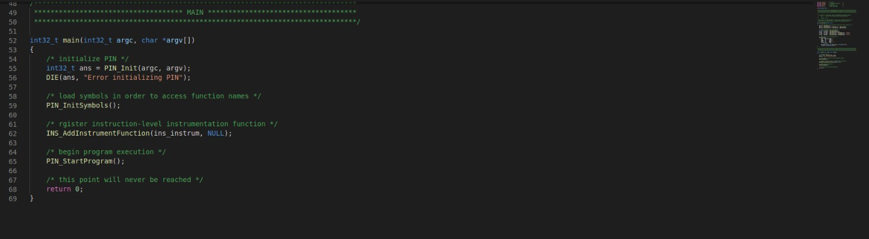
- Instrumentation Callbacks
Command /third_party/pin-3.13/pin -t obj-intel64/minspect.so -- ls -l 1>/dev/null and patch:
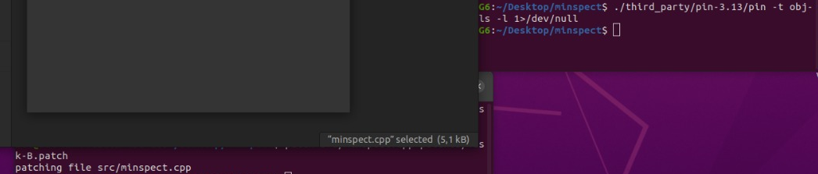

- Code changed again:
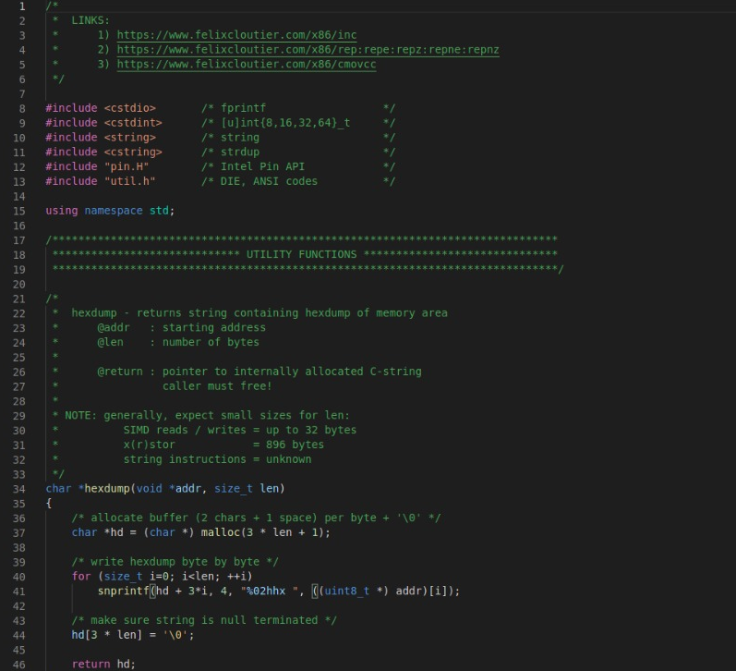
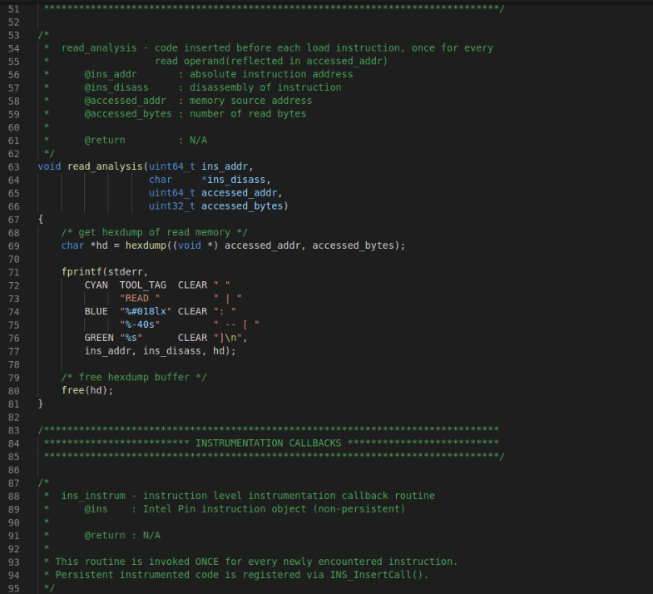
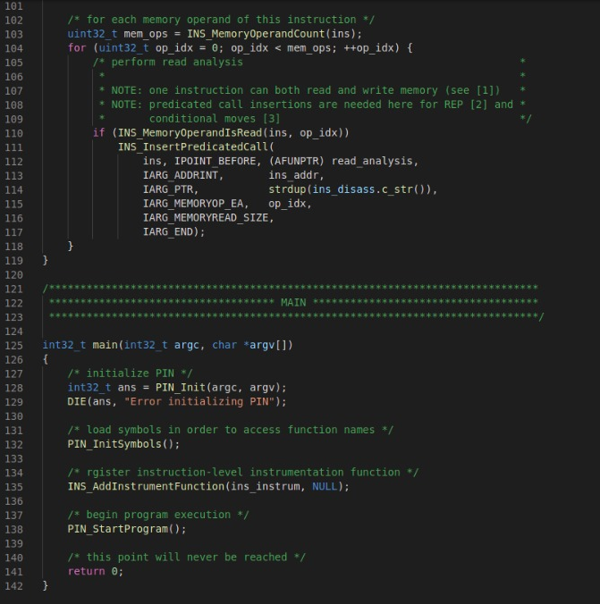
- Command: patch src/minspect.cpp patches/Task-C.patch
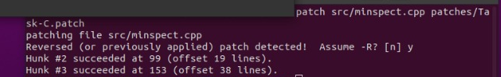
Code for ins_instrum function changed.
- Command: patch src/minspect.cpp patched/Task-D.patch
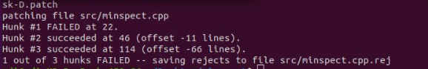
Observed binary dependencies:
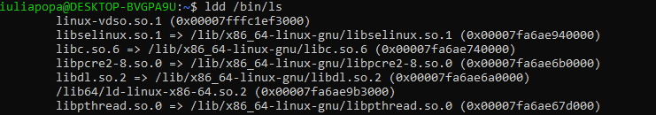

Task 05. Feedback


